IceSmack

*User Guide*

|  |  |  |  |
| --- | --- | --- | --- |
| **Supervisor.** | Sir.Zaman | |  |
| **Batch.** | 2103F | |  |
| **Group.** | 1 | |  |
| **Serial No.** | **Enrollment Number** |  | **Student Name** |
| 1. | Student1307408 |  | Muhammad Fawad |
| 2. | Student1308866 |  | Raheem Ramzan |
| 3. | Student1298516 |  | Harish Kumar |
| 4. | Student1299967 |  | Umair Ali Bhutto |

Home Page

When Site is opened user will be greeted with the home page.



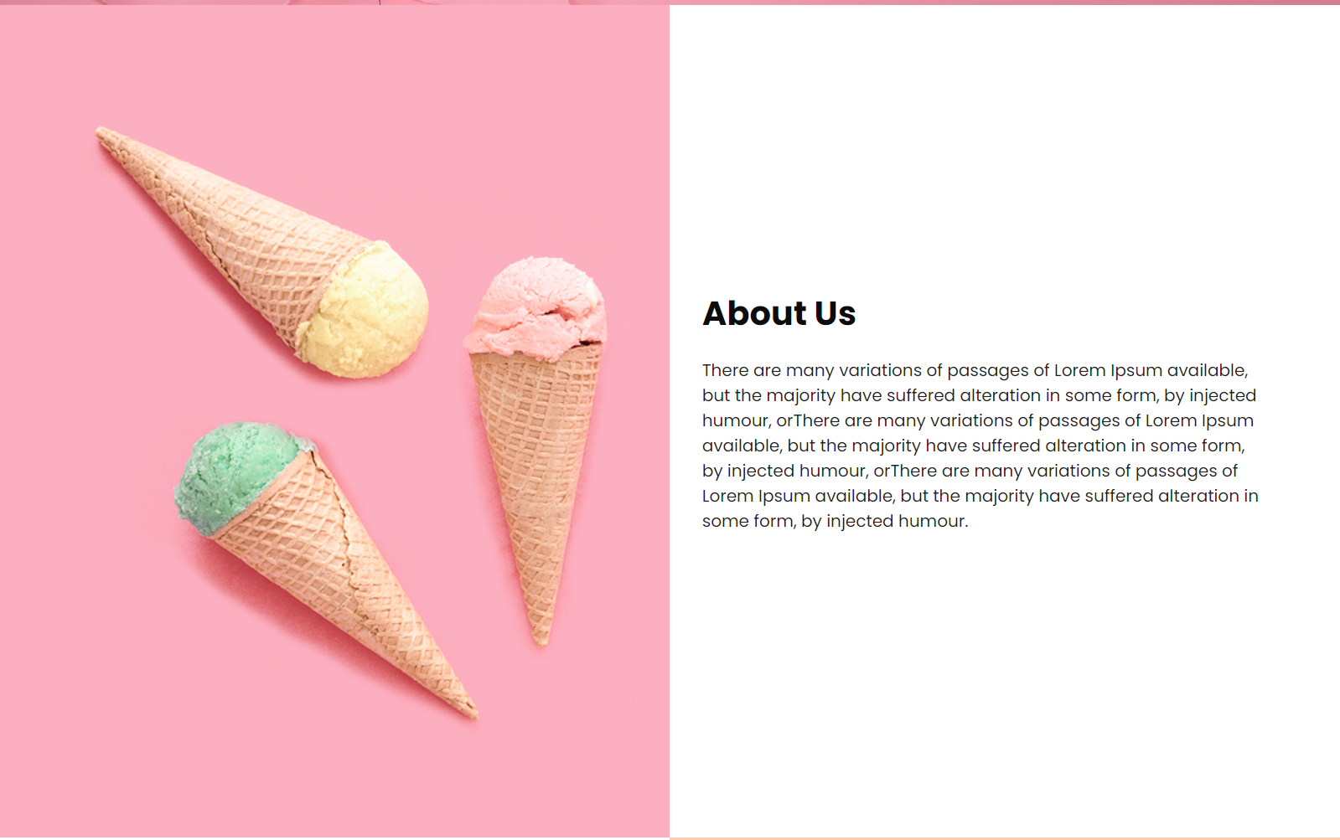

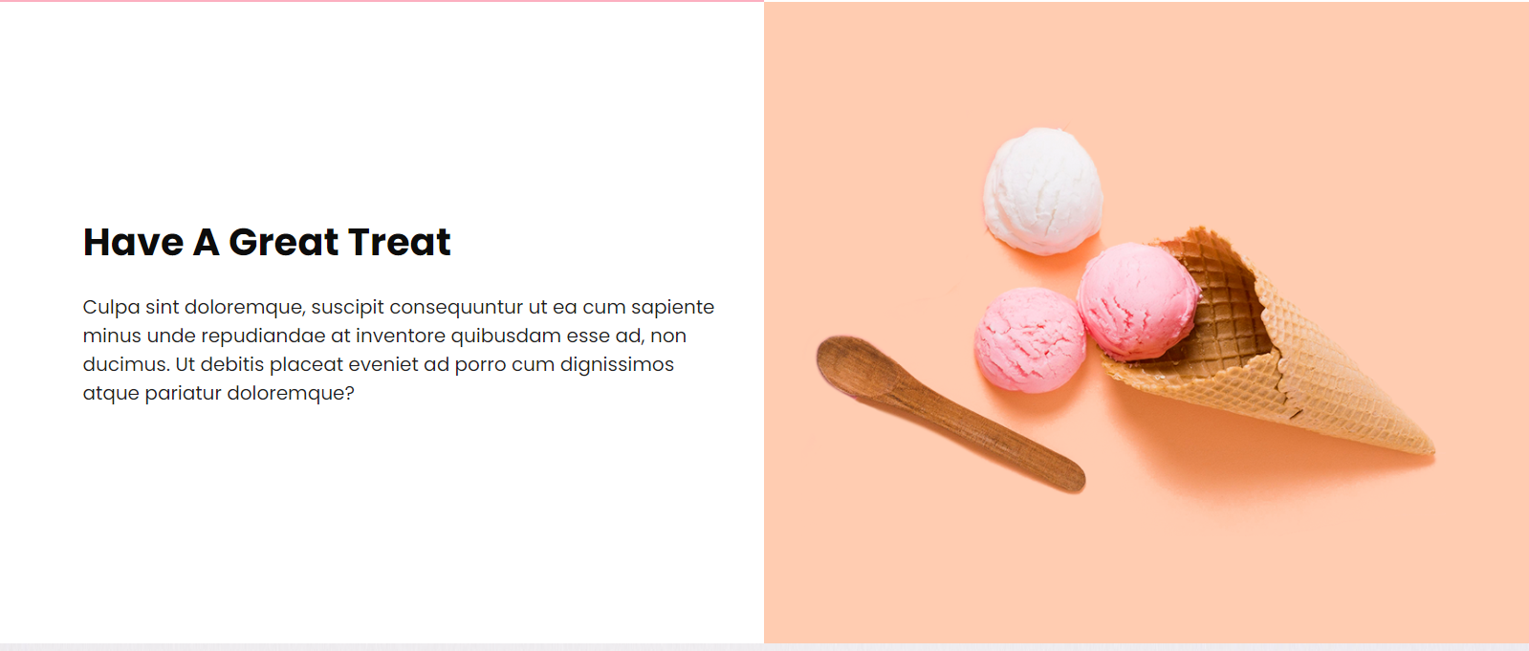



On the homepage you will find the following links.

* Home
* About
* Contact
* Recipes
* Download Recipes
* Feedback
* Login
* Signup



About Page

About page will have the description of the website and the owners.



Contact Us Page

On the contact us page you can reach us physically on site shop.

It contains our address and the pinpoint location of our shop it also contains the timings of our shop.

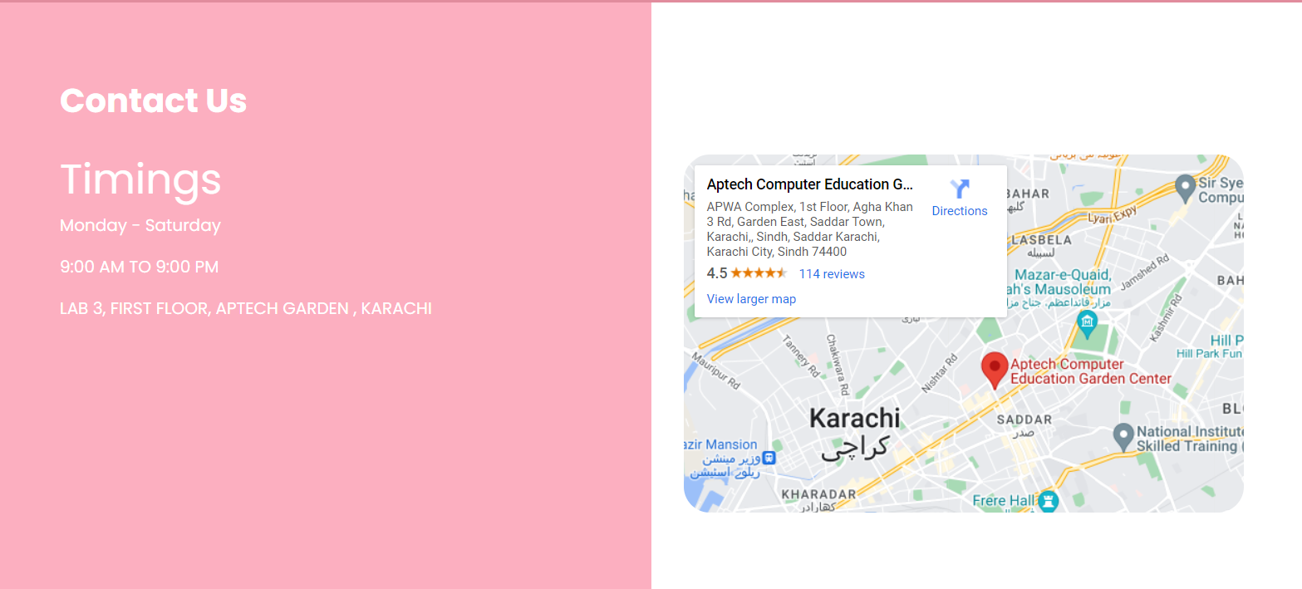

Feedback Page

On the feedback page user can give their feedback and reviews to us about anything like ice cream flavor problems or any suggestions related to our services.

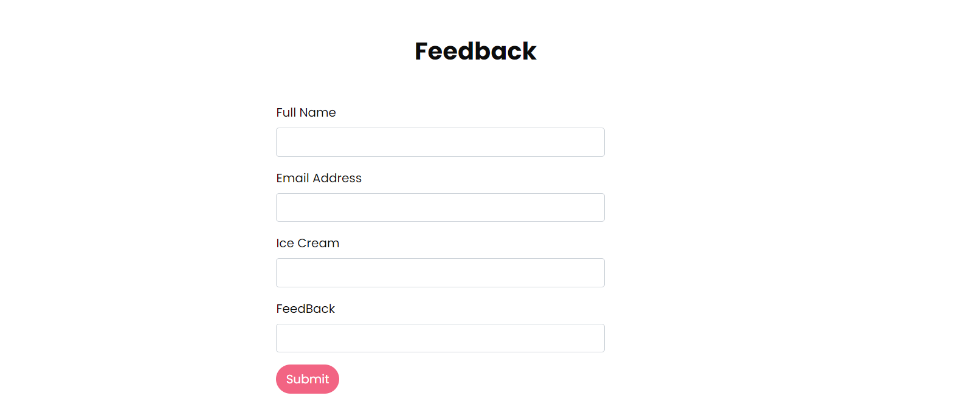

Download Recipes Page

In this page you can download your recipe book

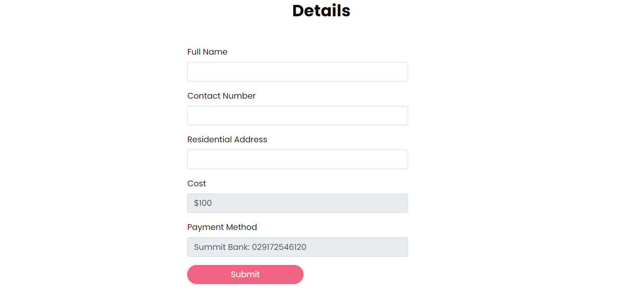

Sign Up Page

User must be logged in to view or add recipes for that user will sign up using the sign up form

Note: User should remember their email and password for login page.

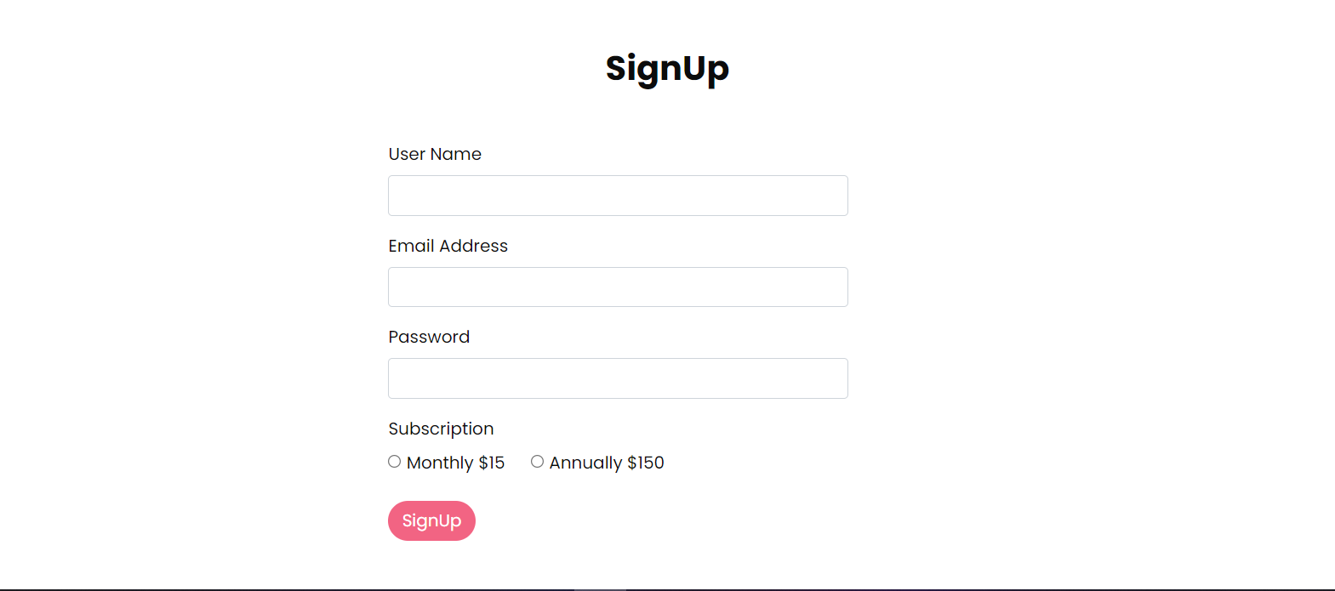

Login Page

After sign up user will login using their email and password

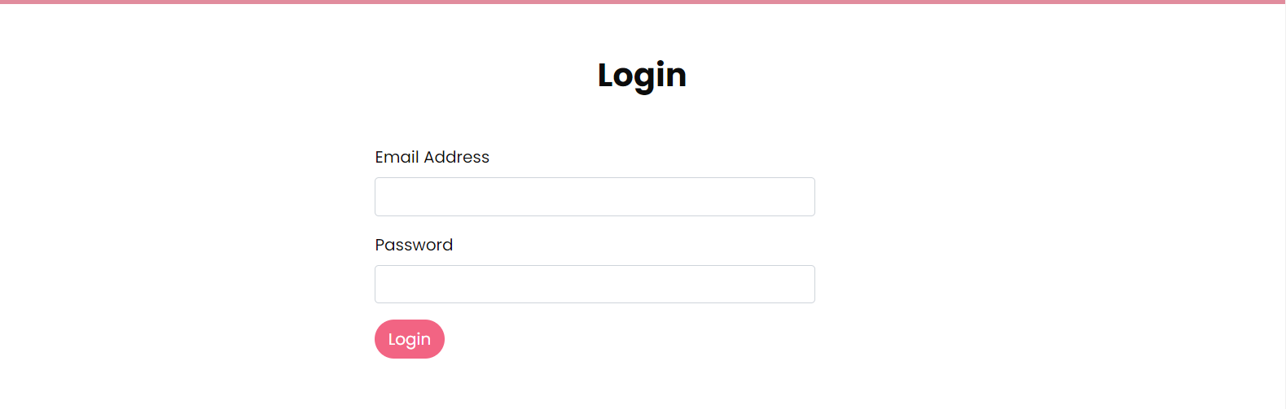

Recipes Page

After clicking the recipes link to view the recipes user must be logged in after successfully logging in user can view all recipes and create new recipes as well.

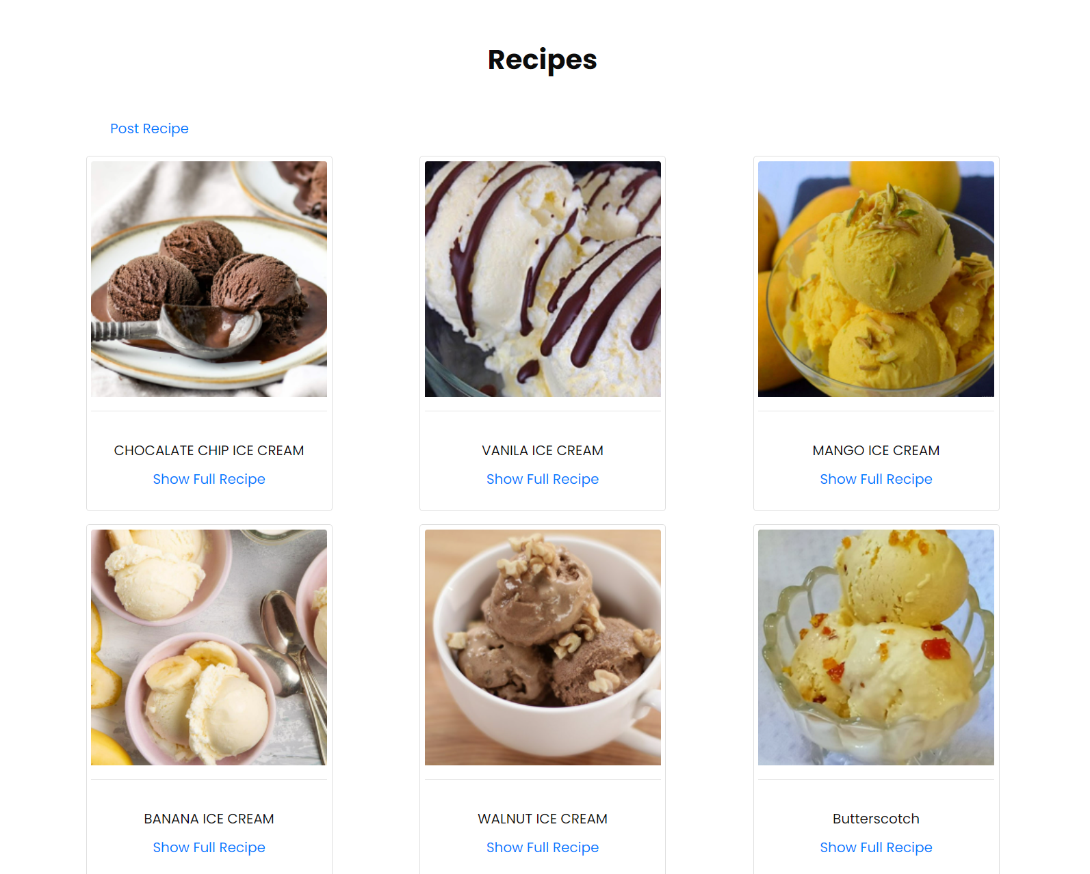

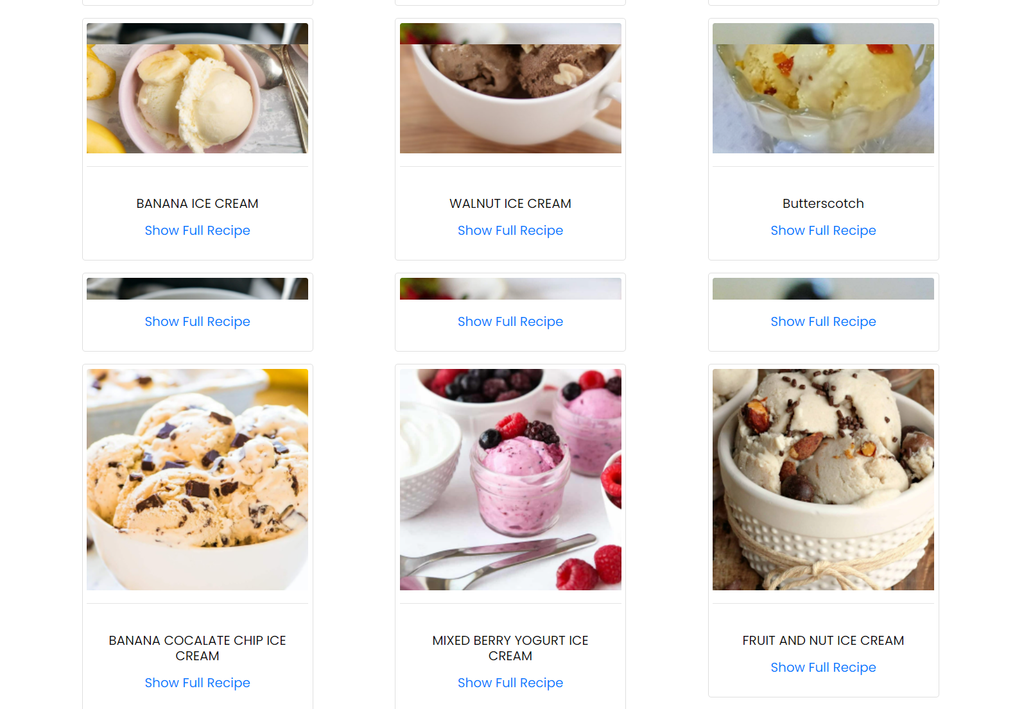

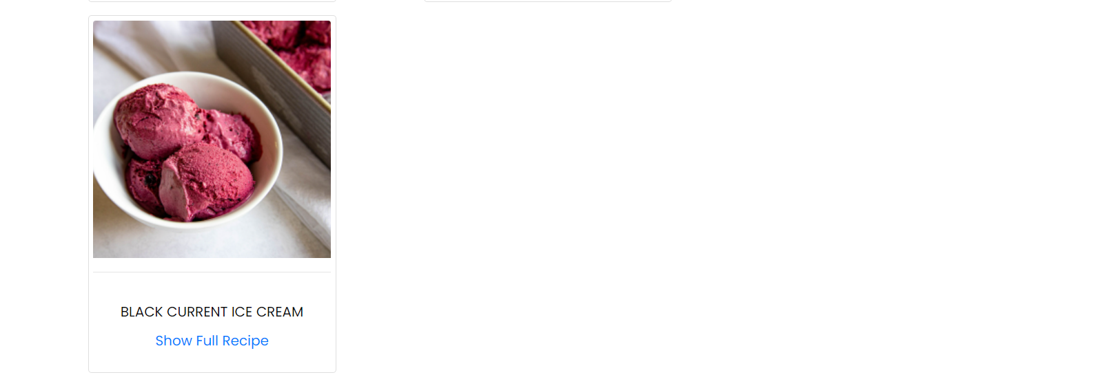

user can click the show full recipe button and can see all the details of the recipe

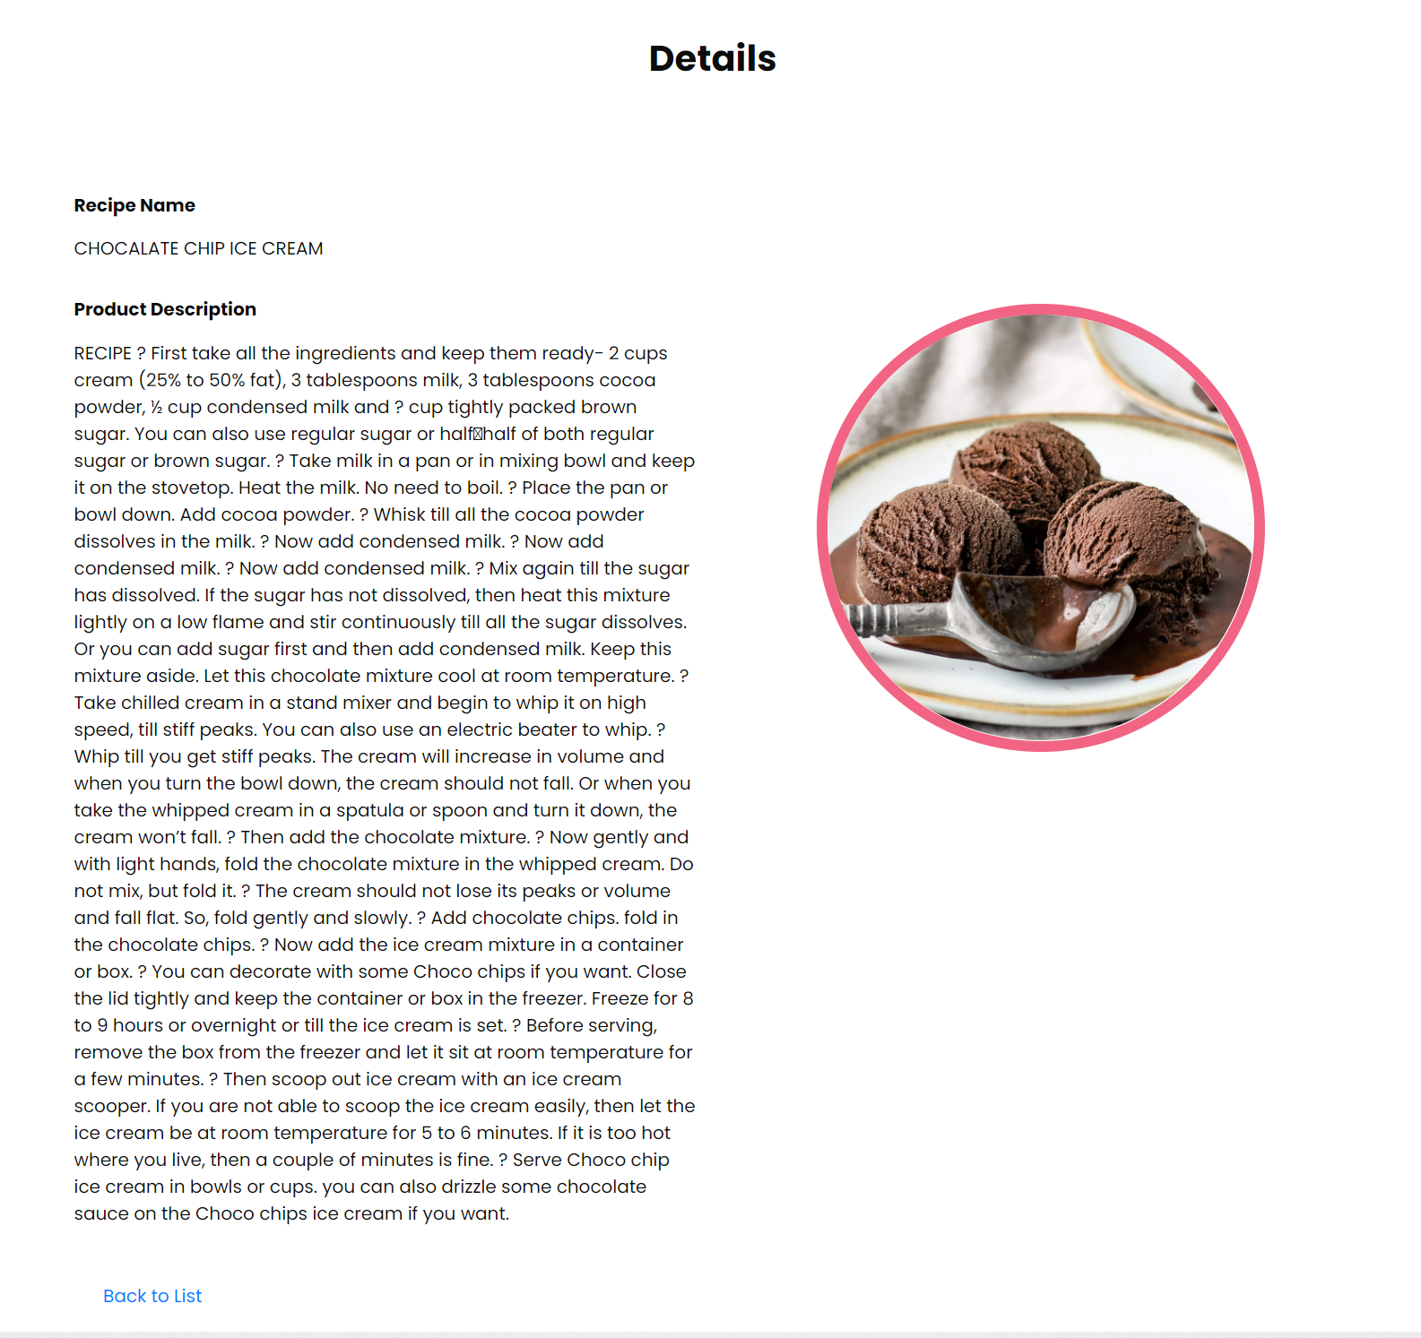

User can add new recipes of their own homemade ice cream by clicking post recipe



After clicking post recipe user will be shown a form where they can add their recipes

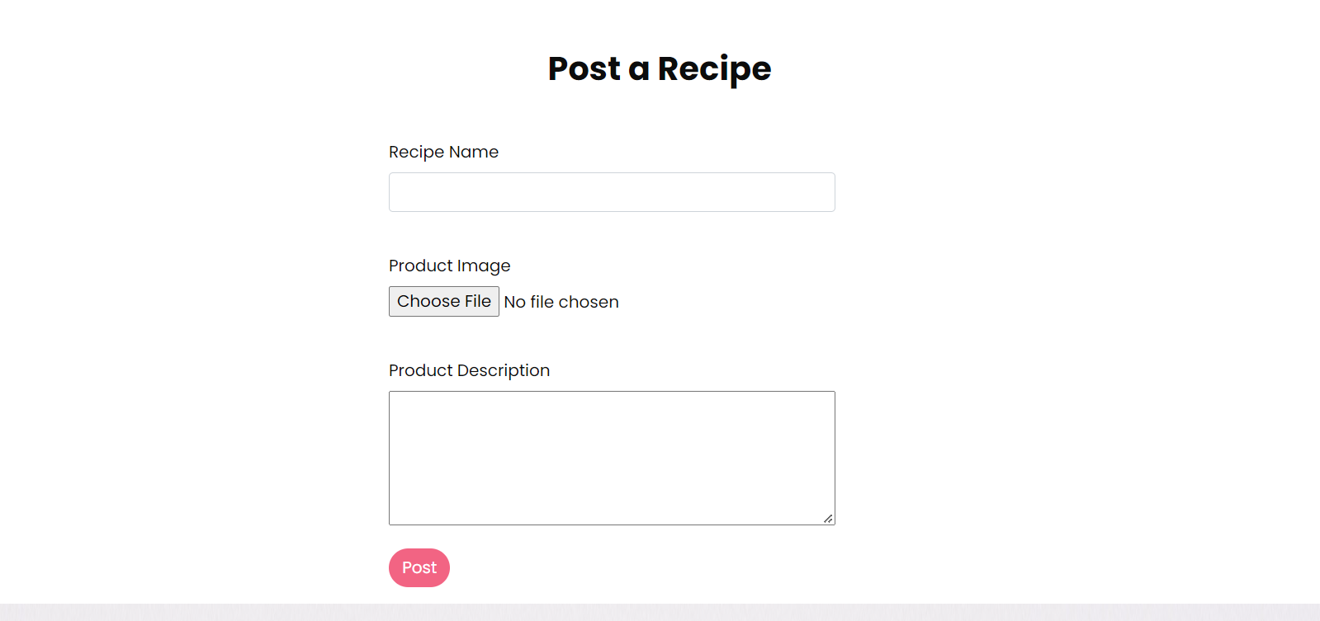

Note: please write correct and appropriate recipe name

Please use appropriate pictures step by step of your recipe

Please write your description of product in numerical list items eg (1)point one.(2)point two.

After everything is done user will logout using the logout button.

